Neural Networks
June 16, 2022
Practice 4 Headlines: Classical conditioning in game playing
Prof. Oscar Chang

Step by step

As we see in previous practices, a neural network can learn to make decisions by taking as inputs complex pixel images.
In the simplest case the network receives an image as input and gives a decision as output without taking into account the sequenciality of the input events. In the psychology of behavior this is called classical conditioning i.e: A neural stimulus is associated with a natural response with no care for sequences.

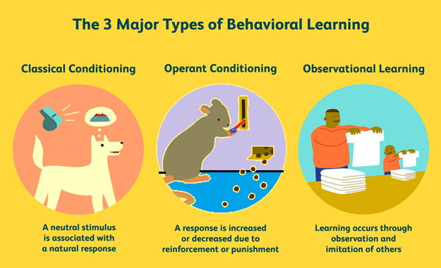

This kind of behavior is very useful in some applications but for more complex situations, where sequentiality is important, more powerful methods such as reinforcement learning (operant conditioning) are required.

For today’s practice we will use a ANN where the token “O” learns to play basic tic tac toe against a random player “X”

Each square in the board is codified with 3 on-off neurons with the following meaning:
010 empty square
001 square contains an “O”
100 square contains an “X”
These signals will be eventually generated by convolutional nets directly from raw video and a web cam.

The board state is thus given by a total of 27 input neurons. Notice that this generates a sparse coding where only 33% of neurons are excited at the same time.
The hidden layer contains 41 neurons
the output layer contains 9 neurons that represent s the decision of the network, that is where the player O is going to place its move.

The idea is to show the network labeled winning positions (input-output) so that the network learns to win.

As we will see later, teaching the network the sequential nature of the game is by far a more complex problem related to reinforcement learning.

For the practice
1.- Run the program, check and understand its training structure.
2.- Tune the net parameters, if necessary, until the network comes to a reasonable training (Exploration).
3.- Once the net is trained and the correspondidng weights saved, add code so that the net takes control of the game and do its own winning moves.(explotation)

4.- Check if the net has gained any knowledge about the game aperture, that is the first few moves on the board. (game aperture connection of present with future)

